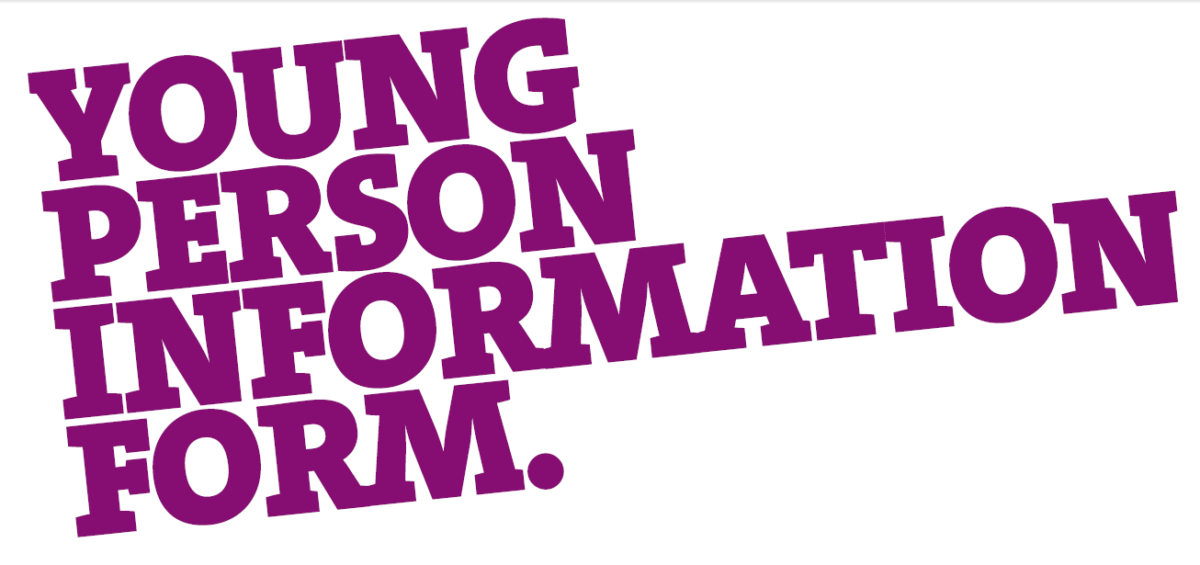
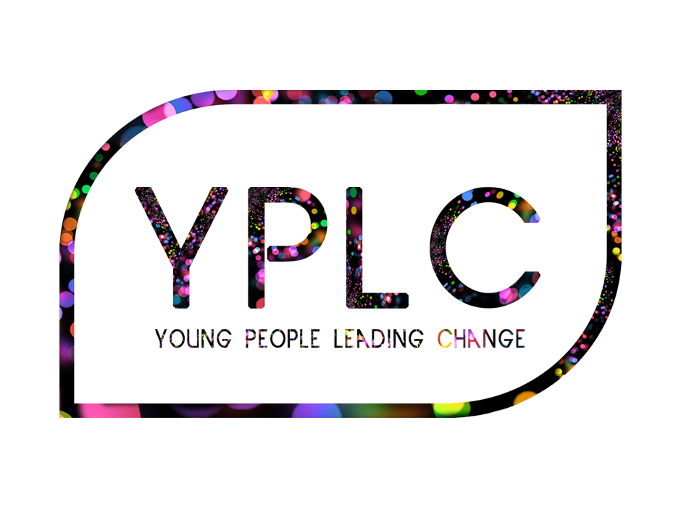
Completed application forms and personal reference should be returned via email or post by 5pm Wednesday 20th February 2019

Contact: Liam Mc Cusker
Address: Holywood Family Trust, 108-112 High Street, Holywood, Co. Down, BT18 9HW
Email: liam.hft@btconnect.com

Holywood Family Trust, 108-112 High Street, Holywood, BT18 9HW
T 028 9042 7842 E liam.hft@btconnect.com

@YPLCNI @yplc_ni


Background

Young People Leading Change (YPLC) emerged in 2013 with the belief that with the right support young-people can make significant contributions towards creating a more positive society in NI. Our vision it to nurture a generation of young-people who are willing and able to lead change. YPLC creates opportunities for young-people to develop their dialogue and leadership potential through working and learning alongside others from different backgrounds both at home and abroad.

YPLC is led by a diverse voluntary group of young-adults from all backgrounds across NI who come together to deliver activities which inspire hope in young-people and society. A key outcome is to develop greater understanding, friendship and cooperation between young-people from all social backgrounds and cultural traditions.

International

Our international project has been running since 2018. The 2019 project will support 28 young people, aged 16 – 19 years old from across NI to broaden their understanding and experience by participating in an international youth exchange project. As well as having time for enjoyment and fun, participants will learn from discussing issues that they identify as important in their lives. Alongside this, they will be supported to develop their capacity to lead similar dialogue with others. The involvement of young people from all backgrounds is greatly valued.

The international project will begin in March and finish in September. It includes structured preparation and evaluation in Northern Ireland, as well as an 8 night exchange in either the Basque region (Spain) or Berlin (Germany) over July.

Project groups: Whilst applications are made by individuals, the participants will work in a project group (consisting of 14 participants and 2 group coordinators). Group structure will represent a balance of all backgrounds, traditions and interests in Northern Ireland. To ensure this balance, we encourage applications from a wide range of backgrounds.

Financial contribution: Participants are expected to fund-raise or contribute a minimum of £350 towards the overall cost of the project.

Application process: All applications will be considered and short-listed accordingly. All applicants will receive a response. Final selection of participants will be carried out on 2nd March 2019 through an informal interview. In order to maintain the full continuity of the learning experience those applying must be available for all dates shown.
Dates

Saturday 2nd March
Selection interviews
15 minute slot during day
Holywood Family Trust
108-112 High Street
BT18 9HW

Saturday 6th April
Induction day
10:30am – 4pm
Holywood Family Trust
108-112 High Street
BT18 9HW

Saturday 4th May
Team-building day
10:30am – 4pm
Holywood Family Trust
108-112 High Street
BT18 9HW

Saturday 1st June
Final preparation day
10:30am – 4pm
Holywood Family Trust
108-112 High Street
BT18 9HW

July 2019
Overseas visit
Young people must be available over July for 8
days (Dates TBC)

Saturday 21st September
Evaluation day
10:30am – 4pm
Holywood Family Trust
108-112 High Street
BT18 9HW

Application form

Section one
Please complete in capitals and black ink

Name

Address

District Council Area

Postcode Telephone No.

Age Date of Birth [Must be over 16 years and under 20 on 1 July 2019]

Email Mobile No.

Religious Tradition School attended Town

Employer if unemployed or still at school at present, please state

Where did you hear of the programme?

Why do you wish to take part?
What do you think you can offer and what can you get from this programme?

Section two

Are you from an area, or do you consider yourself part of a group or community that has been affected by division, community tensions or wider prejudice?

Detail any experience you may have of travel outside of Northern Ireland

How would you plan to raise the £350 towards the cost of the programme?

Tell us about your interests, including membership of youth, community or cultural organisations etc.

For operational and insurance reasons, please specify any medical conditions or special needs that you may have, in the understanding that failure to disclose this information may disqualify you at a later date. If you are currently undergoing treatment, please provide a reference from your doctor confirming your suitability for taking part, particularly on the project overseas.

Is there any additional information that you think may be relevant to your application?

Please include a personal reference from an appropriate adult who is not a family member e.g. Youth Worker, Teacher or Employer, detailing your suitability to undertake this programme. It is important that this reference should comment clearly on your potential to make your own contribution to the community on finishing the programme. Your application can not be considered without a reference.

