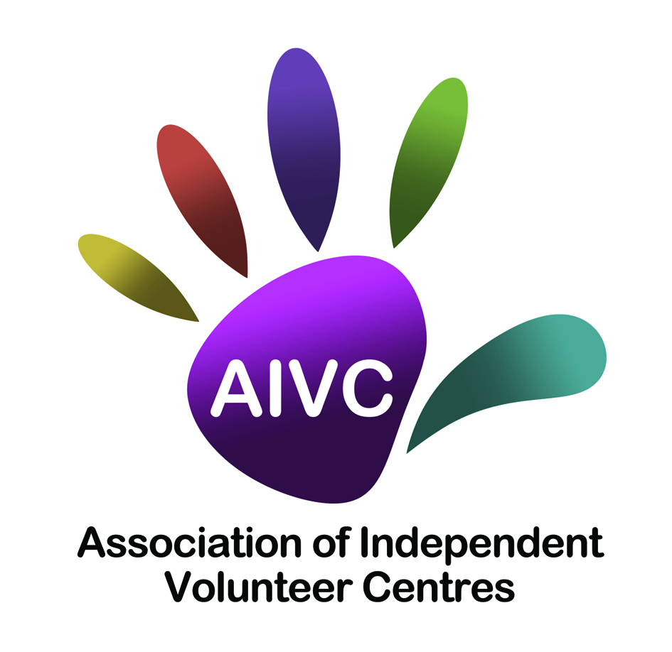
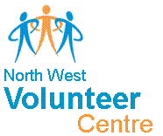

This is an application for funding for a Small Grant to support local volunteer involvement. This is a DfC initiative which is being administered by Limavady Community Development Initiative (LCDI) who have been appointed as an Intermediary Funding Body (IFB). Any grant awarded will be for up to a maximum of £1,200 and will directly support the key objectives of the DfC Volunteering Strategy and Action Plan.
LCDI are the delivery partner for the following: Association of Independent Volunteer Centres (AIVC: Causeway Volunteer Centre, Craigavon & Banbridge Volunteer Centre, Limavady Volunteer Centre, Mid Ulster Volunteer Centre and Omagh Volunteer Centre) and North West Volunteer Centre.

Note: This grant is only eligible for expenditure incurred from the date of award until 31 March 2020.

VOLUNTEERING SMALL GRANT APPLICATION FORM
This form should be completed by the principal contact person for this application

- Name and address of organisation:

Contact Person
Name of Organisation
Address
Post Code
Contact Number
Email |  | Website
Council Area
How did you hear about this grant?
What category does your group fall under?

2 Name of the person with responsibility for volunteers in your group / organisation:

3 If your group is part of a larger organisation, please name this organisation below:

4 What was the annual income of your organisation in the last financial year? (Note if organisations have an annual income of more than £100,000 they are not eligible to apply)

- Does your group have reserves?

Yes

No

If Yes, please state the amount and whether your organisation holds a policy to support the holdings of these reserves (Reserves Policy).

- In order to be eligible, organisations must have an agreed constitution. Do you have a constitution in place?

Yes No but will complete by date

- Please list your organisation’s main activities:

8. Bank Details.

Account Name:
Bank/Building Society Name:
Bank/Building Society Address:
Sort Code:
Account Number:

9. How many volunteers are currently involved with your organisation?

Management committee |  | Others

10. How many of these are:

Not in paid work |  | Young people (16-25)
People with disabilities |  | Older people (65+)
Ethnic/Racial minorities

11. How many new volunteers do you expect to recruit?

12. How many new volunteers do you expect to be:

Not in paid work |  | Young people (16-25)
People with disabilities |  | Older people (65+)
Ethnic/Racial minorities

13. Do you have any paid staff? If so how many:

Objective 1 – Please see notes

- What will you do specifically, to attract people from the under-represented groups you listed in Q12?

Objective 2 – please see notes

15. Please state what new methods you will use for the recruitment of a diverse range of volunteers?

Objective 3 – Please see notes

16. Please state how you will create a supportive environment that will encourage the local community to become more involved thereby increasing inclusion and diversity?

Objective 4 – Please see notes

- Please describe how your grant will enable your group to add benefit to the community?

18. How many hours will the volunteers contribute each month?

19. Who are the key beneficiaries of the activities funded by your grant?

20. The maximum grant you can apply for is £1,200. Outline below how you will allocate the grant applied for:

Volunteer Expenses:
Volunteer Recognition Event / Thank You Event (Subsistence) | £
Travel | £
PPE (Protective Clothing) | £
Training: (This must be directly related to volunteering)
Details of training: | £
Project Running Costs:
Heat | £
Light | £
Rent | £
Insurance | £
Volunteer Recruitment Activities | £
Other: (This must be directly related to volunteering)
Details of other (Equipment is NOT eligible): | £
TOTAL GRANT APPLIED FOR | £

21. Have you applied to any other funder for the same activity/product?
If so please give details below.

DECLARATION
We confirm that the information in this application is correct and, if successful, we will comply with all requirements of the Volunteering Small Grants Programme.

CHECKLIST The following documents must be attached to your application
Constitution |  | Accounts/income expenditure
Last Bank Statement |  | Volunteer Policy

SIGNATURES
Name | Signed | Name | Signed
Position | Date | Position | Date

Return to: smallgrants@lcdi.co.uk

OR

LCDI Small Grants
24d Benevenagh Drive
Limavady
BT49 0AQ

Closing date: 12noon Monday 28th October

