Food for Life Get Togethers
Emergency COVID-19 Small Grants
Application Form and Guidance
Introduction
Food for Life Get Togethers bring people of all ages and from different backgrounds together through growing, cooking and connecting with good food, with the support of the National Lottery Community Fund.
As part of our small grants offer, we have some emergency funding available to assist with community led responses centred around food and growing initiatives to spend within the next 3 months.
The number of our grants is limited. We have 12 grants of approx. £1000.00 (or welcoming just under) in each of our regional test and learn areas (see map below). We also have £10,000.00 available across Greenwich and Middlesbrough.
Due to the number of applications we anticipate receiving, we reserve the right to close the application round early.
For more information on the Food for Life Get Togethers programme, visit our website.
Applicants we will consider:
- Not-for-profit, small scale organisations that are locally based and community focused and led. For example, community groups, voluntary and community sector (VCS) and charities that are immediately responding to the COVID 19 crisis within their communities in 3 months commencing (of your payment date).
- Small businesses and business networks that are immediately responding to the COVID 19 crisis, especially those partnering with not-for-profit small-scale community focused groups and organisations within their communities in the next 3 months.
- If you have received a FFLGT small grant in the past, you are able to re-apply in relation to our current COVID 19 response criteria outlined below.
- If you are already a FFLGTs local commissioned partner, you are able to apply for this small grant round, in relation to our current COVID 19 response criteria outlined below.
- We are open for applications within our following regional test-and-learn areas (see map below) and nationally we are accepting applications from organisations within Middlesbrough and Greenwich
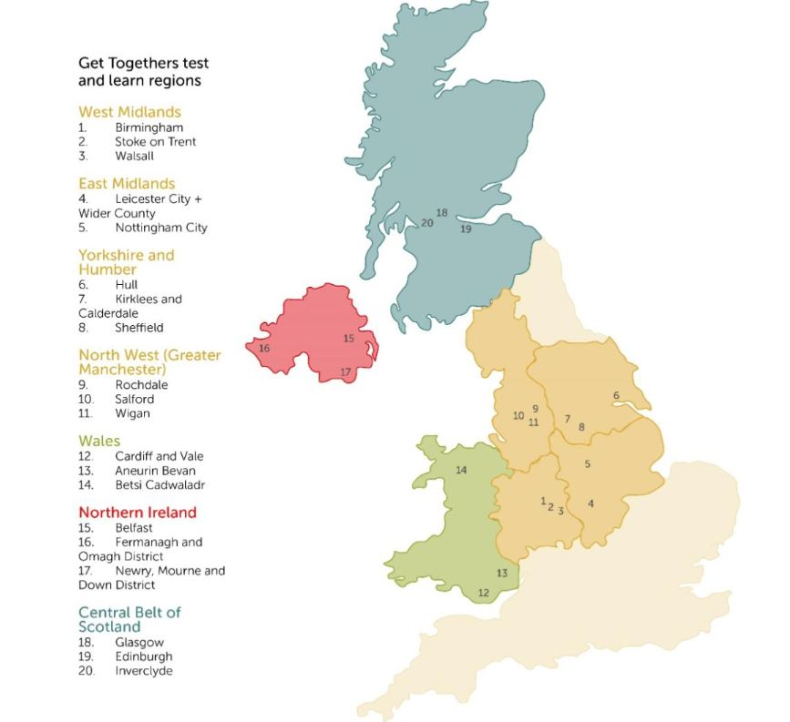

Our funding criteria:
- Initiatives responding to localised food poverty and food insecurity (e.g. community led food aid, food supplies and distribution).
- Initiatives that remotely connect people and groups through good food cooking, growing or connections.
- Equipment costs for community led responses (e.g. digital support, packaging, refrigeration cooking, PPE).
- Transport costs, e.g. of food supplies, petrol, volunteer costs.
- Initiatives responding to reducing experience of social isolation and loneliness through good food-based activity (e.g. digital equipment and training, virtual activities, a chance to chat on a doorstep).
- Growing food, initiatives that respond to community needs to cook, grow and connect through good food, (e.g. doorstep food deliveries or community collection of seed & soil to grow, digital growing support).

Applications we won’t consider:
- We recognise and value newly formed, informal groups that have been set up in response to the Covid-19 crisis but for financial security reasons we will decline any grant applications where there is no organisational or community group bank account to transfer the grant into. We cannot fund grants into personal bank accounts.
- We will not consider any applications which involve promoting any corporate organisation, political activities or promoting any religious beliefs. We will consider projects led by religious organisations if they're for the good of the whole community.

- We will not consider responses that have already happened or will be finished before the grant payment can be made according to our payment timeline – see below.

- We will not consider applications for funding loss of income.

- Will not consider applications to pay staff salaries in part or whole, however we will accept to cover reasonable volunteer costs.

- We cannot accept postal applications at this time, due to all staff working away from our office.
Minimum documents required:
As part of our financial safeguarding procedure, for applications we request evidence of your organisation’s bank account in the name of the organisation with at least two signatories.
We will also be carrying out financial checks on a random sample of successful applicants and therefore you will be required to keep receipts and proof of purchase. Please see Terms and Conditions (no.4 below) for more information.
Timeline:
Our small grants application round follows the timeline:
Opens | Closes | Paid
Monday 20th April 2020 | Tuesday 28th April 2020 | Thursday 7th May 2020

Please send your completed form and supporting financial safeguarding documents by Tuesday 28th April before 5.30pm to: fflgtsmallgrants@foodforlife.org.uk
We reserve the right to close this emergency funding round earlier than the closing date stated should we be over subscribed.

How we will process your application
Due to the number of applications we receive, we cannot acknowledge receipt of them.
If you do not hear from us that your application has been successful by Thursday 7th May 2020, you can assume you were not awarded a grant. Unfortunately, we cannot provide feedback for unsuccessful grant applications.
We may ask you for further information. We aim to deal with all applications in a friendly and efficient manner, if we fall short of these aims, please let us know.
Grant Terms and Conditions
- The grant may be used only for the purposes outlined by your organisation in your grant application and may not be spent on anything else. We understand that your response may change as the COVID 19 situation within the UK develops. If you are unable to use the grant for the specific purpose for which it was intended and significant changes are likely to be made to your response please contact us before spending any portion of the grant. Grants must be spent within 3 months of receipt.
- The grant cannot be transferred to another third party.
- We will require repayment of a grant if you become insolvent or go into administration, receivership or liquidation.
- We will be carrying out financial safeguarding checks on a sample of successful applicants. Therefore, we request the right to receive your proof of purchase in the form of receipts. We will expect to see receipts within 14 working days from the date requested.
- If your organisation does not meet the requirements set out in this document, then we reserve the right to reclaim some, or all, of the grant at any time.
- You can only apply for a maximum amount of £1000.00.
- On completion of your response we would appreciate a case study or a brief write of how your response went for our evaluation and reporting purposes. We are as keen to hear what went well as what went not so well in your responses. Your support with this learning would be valued.
Health and Safety Considerations:
- Your personal safety when delivering the response and the safety of those who are benefiting from your response is extremely important during these times. Use your own organisation’s policies and procedures to ensure you think about, plan for and apply the general related risk assessments, including the safeguarding of children or young people or adults at-risk during your intended community response.
- Ensure that you are always following the latest government COVID 19 guidelines. Country specific: England, Wales, Northern Ireland, Scotland.
- Ensure that you are always following the latest NHS COVID 19 guidelines and advice.

- It is likely that you may have recruited new volunteers or utilising existing volunteers. Please read and refer any volunteers to the Government’s ‘How to help safely’ guidance (Sections 1, 3 and 7 specifically). For more advice, visit the NVCO website.
- In any food related responses, you should follow the latest Food Standards Agency guidance.
- We ask that you don’t promote or give any medical advice.
- For advice on GDPR and data protection during your response, please see the section ‘Data Protection’ on the NVCO website to minimise risk.
Communications and Marketing:
- We expect that any press releases referencing the response funded be forwarded to the Food for Life Get Togethers Communications and Marketing Team – to Cat Dickie, CDickie@soilassociation.org
- Any publicity of the grant funded activity must reference Food for Life Get Togethers and The National Lottery Community Fund.
- You agree that we can use any of the information and images you've provided us with in any of our publicity or marketing.
Privacy Notice:
1. As part of the requirements of The National Lottery Community Fund, Food for Life Get Togethers is required to keep any information for 7 years. An extract of this retention policy is available on request. Unsuccessful applicant’s information will be destroyed, as well as successful applicants bank details once payment is made – although a record of payment will be held by Soil Association Accounts team.
2. We may share your details with others internally working for Food for Life Get Togethers who help us assess, manage and process your grant application.
What else we may do with your data if your grant application is successful?
1. You will be added onto our database so we can access your contact details and send you future and marketing updates.
2. You may be contacted for further evaluation.
3. We may contact you for future communication and marketing opportunities, for example a case study on what you did with your grant.
If you have any worries, complaints or want to OPT OUT in regard to the way we will use your information, please don’t hesitate to get in touch with us.
Grant Application Form
All applicants must fill in this form. Please send your completed form and supporting financial safeguarding documents by Tuesday 28th April before 5.30pm to: fflgtsmallgrants@foodforlife.org.uk
Personal Details
Name of organisation, group or setting applying:
Company/charity registration number:
Name of individual submitting the application and your role within the organisation:
Email address:
Phone Number:
Your website address, if you have one:
Address where the response will be delivered from (please ensure you include the postcode):
Which of the Food for Life Get Together test and learn areas are you based in?*See map on page 2 or state Greenwich or Middlesbrough.
Grant request
How much are you applying for? Max. amount is £1000.00):
‘Name response or initiative goes by’:
What date (or dates) will your response be delivered?
Please list what will you spend the grant on if successful and provide approximate expenditure breakdown of costs.
Please describe how your Covid-19 response will be delivered.
In no more than 300 words, please tell us:

- Who will benefit?
- What do you think will be the main benefit or outcome of receiving the grant?

Will you be working with other local organisations/partners when delivering your response? Please list.
Communications and Marketing
Would you be willing for us to share your experience of receiving a grant through our website or social media? | Yes/No
Evaluation and Monitoring
If you are successful can we contact you in the future to hear the story of your response for our evaluation? | Yes/No
Bank Details
Name of bank/building society
Address of bank/building society
Account Number:
Sort Code:

Please note that the money will be sent from Soil Association Ltd which will appear on your bank transactions.
By signing below, you are agreeing to the grant terms and conditions and privacy notice.

Signed by: ……………………………………………………………………………………………..

Date: ………………………………………………………………………………………………………..
Contact
If you have questions relating to the submission of your application please email them to fflgtsmallgrants@foodforlife.org.uk
Please send your completed form and supporting financial safeguarding documents by Tuesday 28th April 2020 before 5.30pm to: fflgtsmallgrants@foodforlife.org.uk

