Our website has a search function where you can look for volunteering opportunities near you. You can find this by clicking here>> Volunteering - Volunteer Now - Opportunity Search

It should look like this.

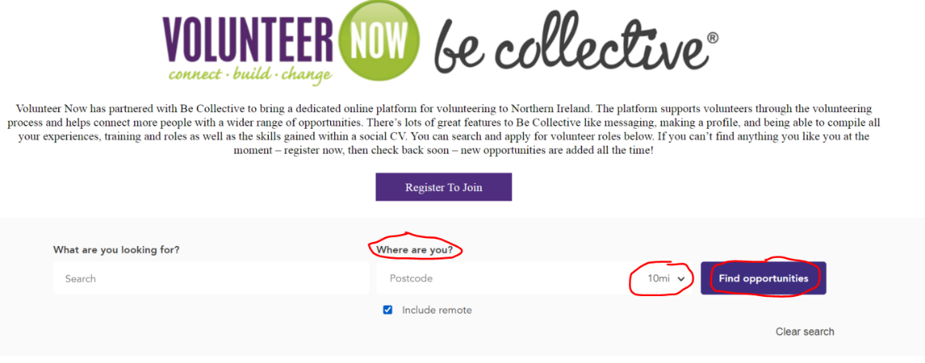

In the areas marked by red circles, please type in;
- where you live (post-code or town) in the box marked ‘Where are You’
- Select how far you can travel to volunteer (in miles)
- Select ‘Find Opportunities’

This will then show you all the volunteering roles near you, you can scroll through these and click on them to read more about the role and apply to join.

ALTERNATIVELY

If doing this is difficult then you can call or email your local Volunteering Support Officer
David Moore <david.moore@volunteernow.co.uk>
Wenda Gray <Wenda.Gray@volunteernow.co.uk>
Michaela Traynor <Michaela.Traynor@volunteernow.co.uk>
Clara O'Callaghan <Clara.O'Callaghan@volunteernow.co.uk>
and ask them to search for you. To help with this you will need to answer the following questions.

- Why do you wish to volunteer?
- When you could be available to volunteer?
- Where do you live and how far you could travel to volunteer?
- What work or volunteering experience & skills you have?
- What types of things do you enjoy?
- What level of English do you have?
- Are you in N.I. as a refugee, asylum seeker or migrant?

They will then use this information to try and find a volunteering role for you and contact you with the results of their search – please be patient with this as it may take a few days to find something.

PLEASE NOTE: Volunteer Now is an English-speaking organisation and you will need to provide answers in English as this is the only language our staff can speak & read.

