Boggeena website-ka waxa uu leeyahay qeyb raadin aad ka heli karto fursadaha shaqo ee iskaaga wax u qabso ah (folentiir) ee adiga aad kugu dhaw. Halkaan ayaad kaheli kartaa haddii aadku dhufato>> Volunteering - Volunteer Now - Opportunity Search

Waxa ay u egtahay sida tan.

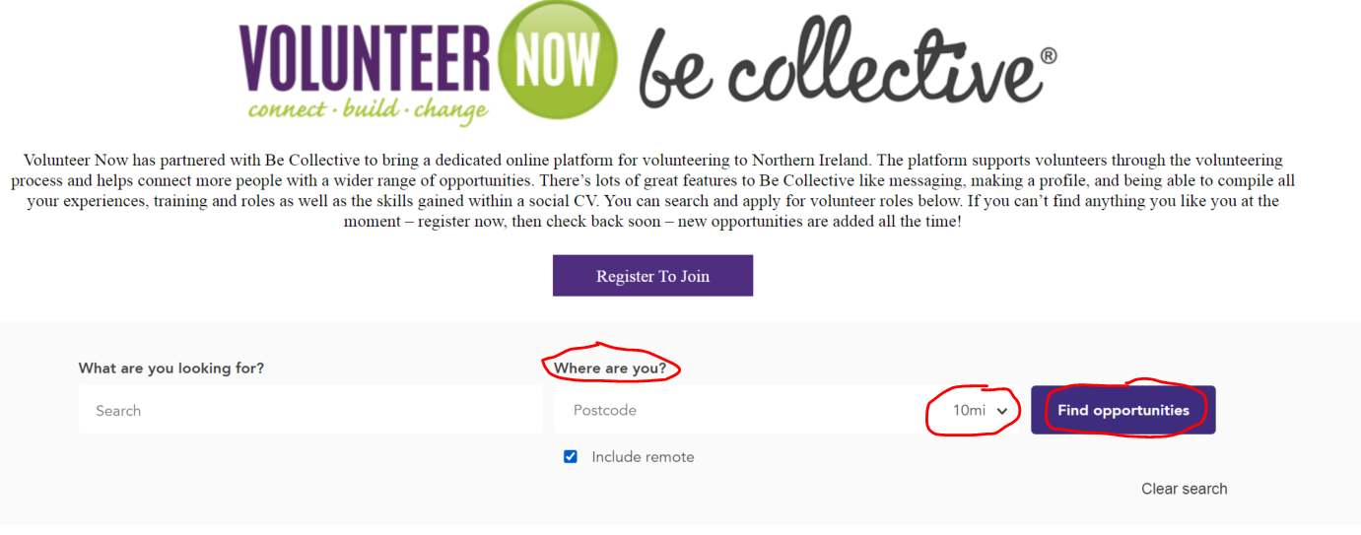

Waxaad ku qortaa goobaha goobabinta gaduudan ku jira;
- Halka aad ku noshahay (post-code ama town) boxkiska ku qoran 'Where are you (halkee joogta)'
- Dooro inta aad rabto in aad us socdaasho howsha folentiirka (fogaantu waa maylis)
- Dooro 'Find Opportunities (Hel fursado)'

Tani waxa ay ku tusineysa in dhamaan howlahah folentiirka ee kugu dhaw, waxaad hoos iyo kor u raaci kartaa adigoo wax badan ka aqrinaya doorka howsha si aad u codsato.

MIDAAN BADALKED

Haddii ay kugu adag tahay in aad sidaan sameyso waxaad wici kartaa ama fariin iimeyl ah u diri kartaa Sarkaalka Taagerada Folentiirka
David Moore <david.moore@volunteernow.co.uk>
Wenda Gray <Wenda.Gray@volunteernow.co.uk>
Michaela Traynor <Michaela.Traynor@volunteernow.co.uk>
Clara O'Callaghan <Clara.O'Callaghan@volunteernow.co.uk>
adigoona weydiisanaya in uu kuu raadiyo. Si arrinkan laguugu caawiyo waxaa lagaaga baahan doona in aad ka jawaabto su'aallaha soo socda.

- Maxaad rabtaa in aad folentiir ku qabato?
- Goorme lagu heli karaa ood qabaneysa howsha folentiirka ah?
- Halkee ayaad ku nooshahay ilaa iyo inteena safri kartaa?
- Shaqo nuuce ama howl folentiir nuuce ayaad xirfadeeda iyo qibradeeda leedahay?
- Wax yaabaha aad ka hesho maxaa ka mida?
- Waa maxay heerkaaga luuqada Ingiriisiga?
- Ma waxaad N.I> ku tahay qaxooti, magan galyo doon ama muhaajir?

Kadib waxa ay xogtan u isticmaali doonaan in ay kugu raadiyaan shaqo folentiir ah oo adiga kugu haboon ayagoona dib kugula soo noqon doono natiijada xogtaada - fadlan dulqaado waxa laga yaaba in ay dhowr maalmood qaadato si wax laguugu helo.

FADLAN OGOW: Volunteer Now waa hayad ku hadasha luuqada Igiriisiga waxaana lagaaga baahan doona in aad jawaabaha ku bixiso English maadama ay tani tahay luuqada kaliya ee shaqaalaheynu fahmaan.

